**Instructions for Jupyter (python)**

**Installing Jupyter Notebook (do only once)**

1. In your browser, go to anaconda.com

2. In the upper right, click the green download button

3. Scroll down a little and click on MacOS

4. Click the green Download button under Python 3.5 version

5. After it downloads to your downloads folder, double click if it doesn’t open automatically.

**Finding the terminal app and getting it on your dock (do only once)**

6. Once it has installed, open your terminal. Do this by going typing “terminal” and selecting “Name” in the search button on your finder. Then scroll down to the app named “Terminal” which has an icon of a black screen with a prompt to the left (see the screen shot below).

7. Double click terminal.

8. On your dock, right click the icon and go to Options->keep in doc. You will need to use terminal every time you want to open a jupyter notebook



**Running Jupyter Notebook (do these steps each time)**

1. Open terminal by double-clicking the icon on your dock

2. Type jupyter notebook in the terminal and hit return.

3. A browser window will open. You will probably have to click the folder, “CGIforPolarResearch” then “CGI_modules” then the module of interest. Then you will see the home screen, which should look similar to the following:

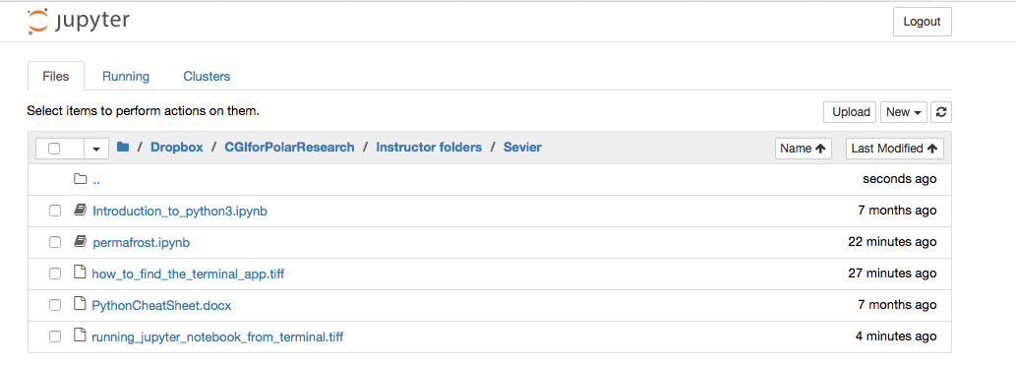

4. Double click the python notebook you want to run. E.g. “Introduction_to_python3.ipynb.” It will open in a new tab.

5. Save periodically by selecting “save and checkpoint” under “File” in the top menu.

6. When you are done, quit the notebook you’ve opened by selecting “save and checkpoint” under File, then “close and halt” also under File. You may need to click a button asking if you want to leave the page.

7. That tab will close on your browser. Repeat step 6 for each notebook you have open, until all that is open is the home screen.

8. Click “Logout” in the upper right-hand corner.

9. Go back to the terminal window and hold down the Ctrl key and hit “c”.

10. Type y and enter. Then type exit and hit enter.

11. Now you can close terminal and the tab on your browser.

12. Congratulations!